AI ASSISTED CODING
1st Assignment :

TASK-1:
Factorial without Functions
• Description:
Use GitHub Copilot to generate a Python program that calculates the
factorial of a number without defining any functions (using loops
directly in the main code).
• Expected Output:
o A working program that correctly calculates the factorial for
user-provided input.
o Screenshots of the code generation process
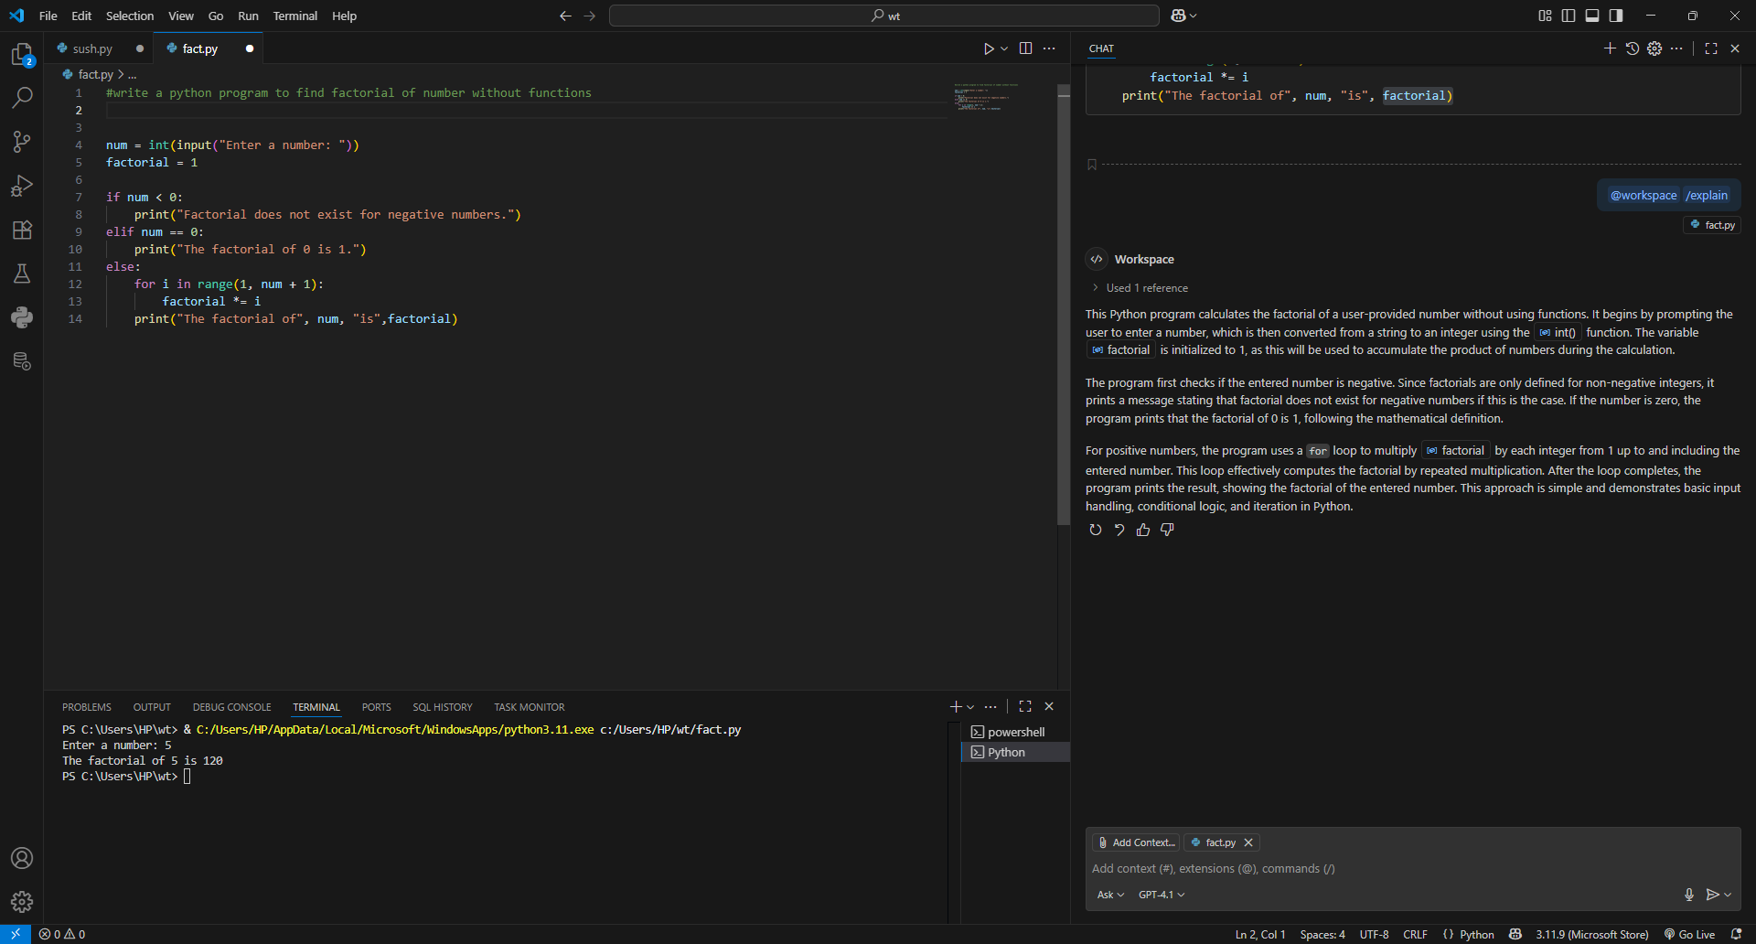

TASK-2:
Improving Efficiency
• Description:
Examine the Copilot-generated code from Task 1 and demonstrate
how its efficiency can be improved (e.g., removing unnecessary
variables, optimizing loops).
• Expected Output:
o Original and improved versions of the code.
o Explanation of how the improvements enhance performance.

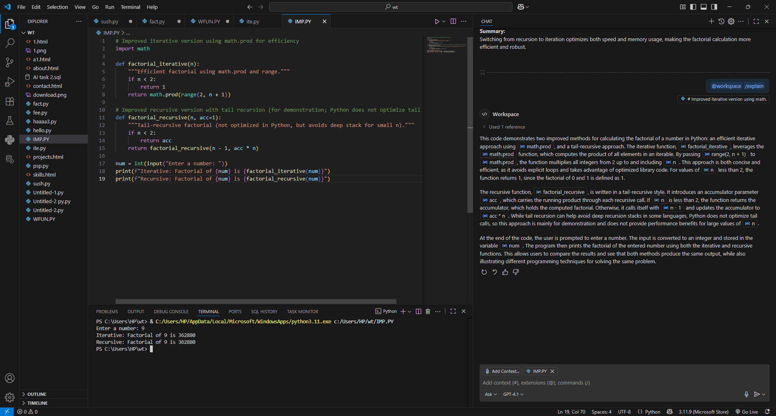

TASK-3:
Factorial with Functions
• Description:
Use GitHub Copilot to generate a Python program that calculates the
factorial of a number using a user-defined function.
• Expected Output:
o Correctly working factorial function with sample outputs.
o Documentation of the steps Copilot followed to generate the
function.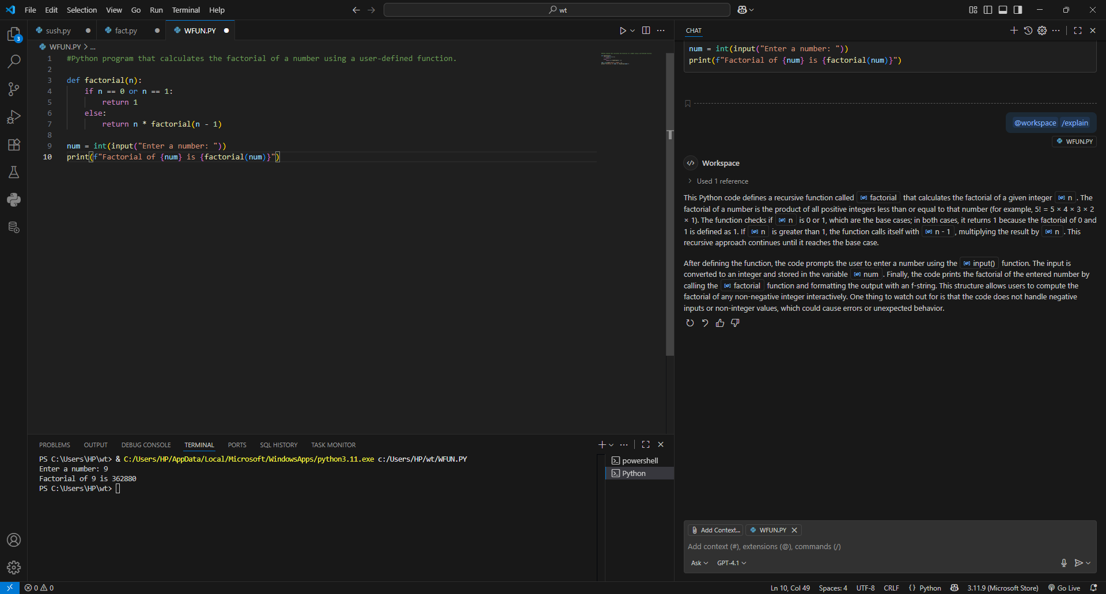

TASK-4:
Comparative Analysis – With vs Without Functions
• Description:
Differentiate between the Copilot-generated factorial program with
functions and without functions in terms of logic, reusability, and
execution.
• Expected Output:
o A comparison table or short report explaining the differences.

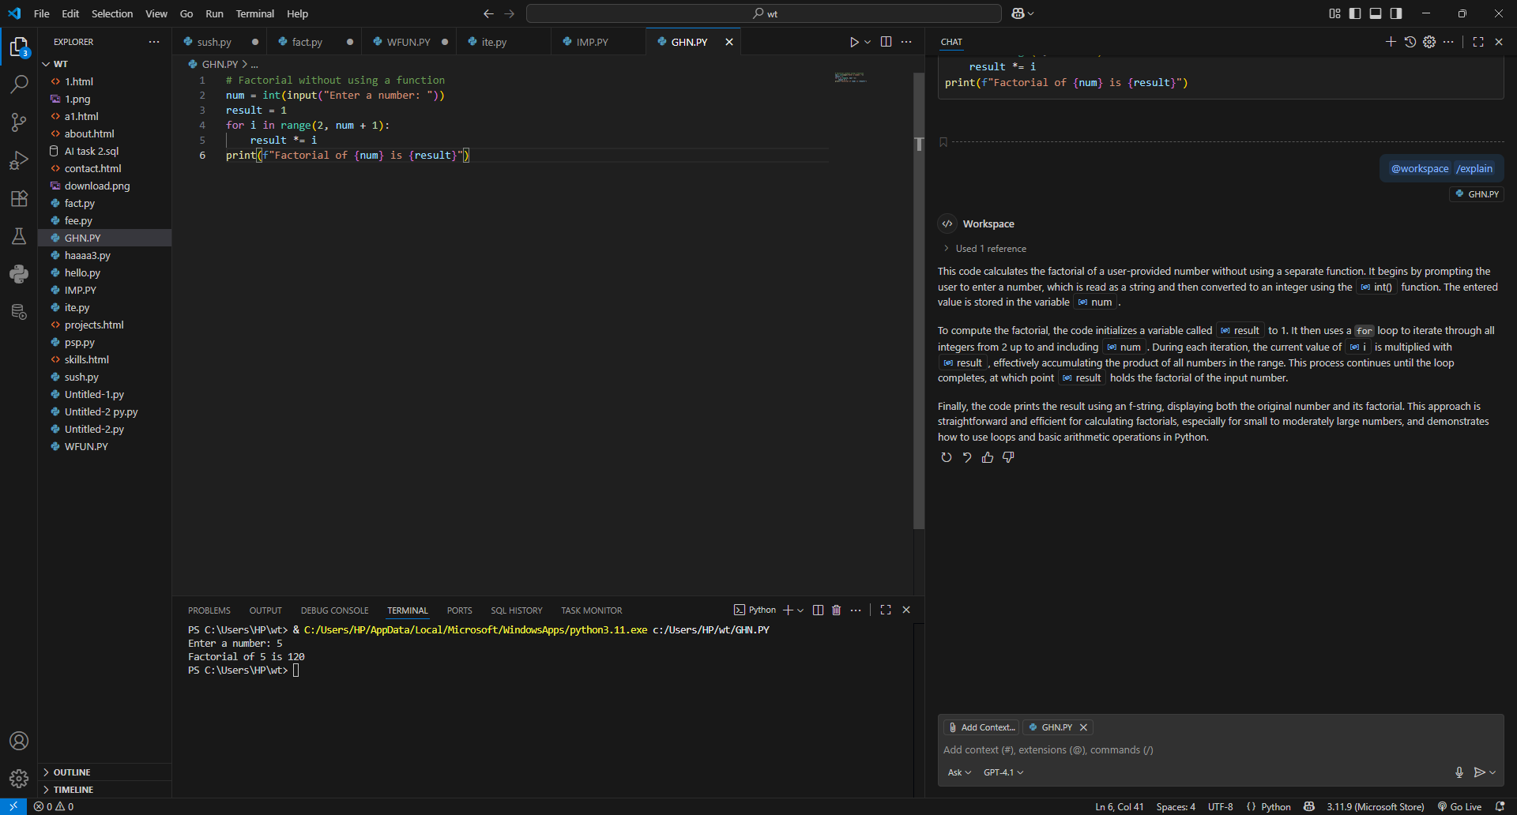

TASK-5:
Iterative vs Recursive Factorial
• Description:
Prompt GitHub Copilot to generate both iterative and recursive
versions of the factorial function.
• Expected Output:
o Two correct implementations.
o A documented comparison of logic, performance, and
execution flow between iterative and recursive approaches.

